**Submission Evidence :**

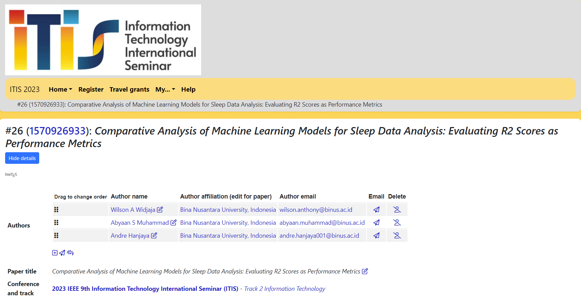

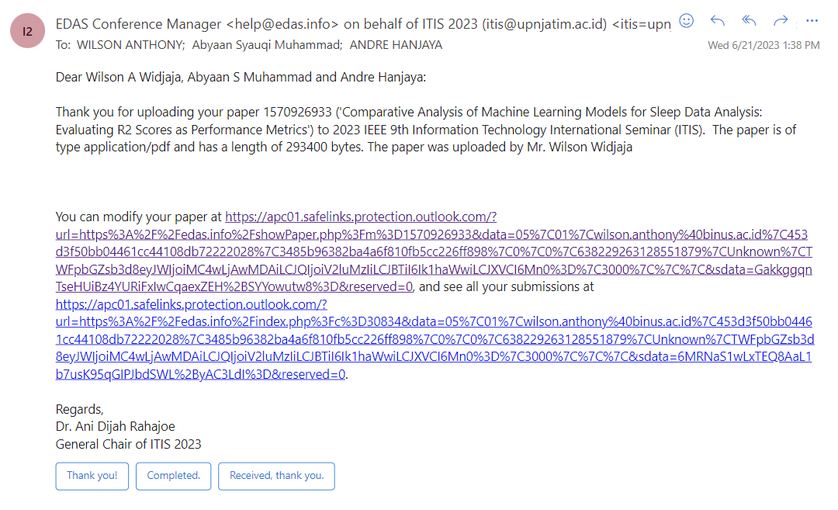

**Website:** <http://2023.itisconf.org/>

**Scope:** The aim of the conference is to stimulate interaction and convergent among researchers active in the areas of Technology, Informatics, and Information Systems. This conference focused on discussing paper that will be presentated for developing and innovating technology.

**Organizer :** ITIS (Information Technology International Seminar) is a conference that organized by Faculty of Computer Science UPN Veteran Jawa Timur Surabaya, Indonesia. This conference first time initiated on April 14th 2009.

**Date and Place :** Batu-Malang, Indonesia, 18-20th of October 2023

**Keynote Speakers:**

Picture taken from the website

Opening speech speaker : Prof. Dr. Ir. Akhmad Fauzi, MMT. (Rector of UPN Veteran Jawa Timur, Indonesia)

Prof. Taufik (Professor of Electrical Engineering, Director of Power Institue, Cal. Poly. State University)

Prof. Drs. Ec. Ir. Riyanarto Sarno, M.Sc., Ph.D (Sepuluh Nopember Institute of Technology Professor won Top 2% Scientist in The World in 2021)

Prof Saman Halgamuge (He is listed as a top 2% most cited researcher for AI and Image Processing in the Stanford database and his papers are cited over 13,000 times with h-factor of 50.